6- Construction Game*(required time:15min)*

*this question should be answered with c#*

You are writing a construction game, you want to let the user configure as many things as they want, with any order. Your boss comes up with a code that let the user add and configure as many things as they want. But it will build the building when the user call the “.Build()”. Here is the code:

#### You can’t change the code below.

|  |
| --- |
| private static void **Main**(string[] args)  {  var myHouse = new Building()  .**AddKitchen**()  .**AddBedroom**("master")  .**AddBedroom**("guest")  .**AddBalcony**();  var normalHouse= myHouse.**Build**();  *//kitchen, master room, guest room, balcony*  Console.**WriteLine**(normalHouse.**Describe**());  myHouse.**AddKitchen**().**AddBedroom**("another");  var luxuryHouse = myHouse.**Build**();  *//it only shows the kitchen after build*  *//kitchen, master room, guest room, balcony, kitchen, another room*  Console.**WriteLine**(luxuryHouse.**Describe**());  } |

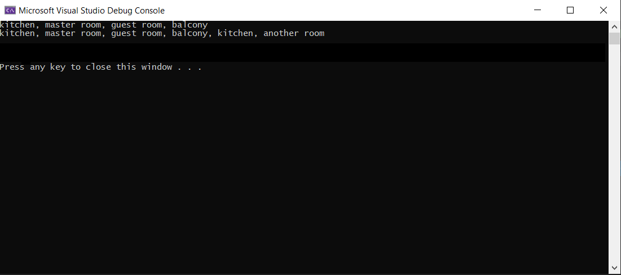

# Answer

Please find my answer and the code accompanied this document.